pH Testing Lab
A pH meter is a useful tool in the greenhouse and each grower should be able to accurately operate the meter. This procedure is for testing your greenhouse water and soil media.
Materials Needed:
pH meter
Glass Beakers
pH solution 4 and 7
Distilled water
Strainer or fine mesh
Testing your pH meter
- Pour a small amount of pH 4 solution into a beaker
- Immerse the pH probe and take the reading. It should read 4.0. If it doesn’t your meter may need to be calibrated.
- Remove probe a rinse with distilled water
- Test the accuracy of the meter again by immersing the probe in a small amount of 7.0 solution. Adjust meter if needed.
- Remove probe and rinse with distilled water.
Testing your greenhouse water
- Collect a small amount of water from your greenhouse into a glass beaker
- Insert the probe of the pH meter and record the pH of the water.
- Remove probe and rinse with distilled water
Testing your greenhouse soil media
- Collect a fresh, dry growing media sample 1-2 days before testing is done.
- Place 1 tablespoon of media into a glass beaker and add 30cc of distilled water.
- Stir and let stand for 20-30 minutes.
- Stir two more times within the next 20 minute period – 40-50 minutes total.
- Obtain a clean beaker.
- Place a strainer or fine mesh over the clean beaker
- Drain the water out of the soil by pouring your soil beaker sample into a strainer allowing the water to pass thru into the clean beaker
- Insert the probe into the water collected and record the pH of the water
- Remove the probe and rinse with distilled water.

Student Response:
What was the pH of the greenhouse water?
What was the pH of the greenhouse growing media?

Let’s apply what you learned
- Why is knowing the pH of your water and growing media important?

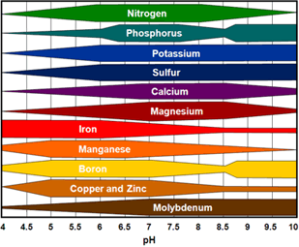
- Using the chart above determine what nutrients are easily available to your plants using only your greenhouse water?

Do the same for the pH of your greenhouse soilless media?

