WHO AM I?
WHEN BABY PIGS ARE BORN THEY HAVE MANY BROTHERS AND SISTERS THAT SHARE THE SAME BIRTHDAY IN A GROUP CALLED A LITTER.
THEIR MOTHER WHO IS CALLED A SOW. SHE CAN HAVE 2.5 LITTERS A YEAR WITH AN AVERAGE OF 9-12 PIGLETS.
A SOW HAS MORE CHILDREN THAN OLD MOTHER HUBBARD, SO WHAT SHE DOES IS WORK WITH THE FARMER AND GIVES EACH OF HER CHILDREN A SET OF NUMBERS SIMILAR TO FIRST AND LAST NAME.
THIS IDENTIFICATION METHOD IS CALLED THE UNIVERSAL EAR NOTCHING SYSTEM
Facing the pig- THE LEFT EAR (their right) IS CONSIDERED THE LITTER EAR OR LAST NAME; WHERE ALL BROTHERS AND SISTERS SHARE THE SAME NUMBER (LAST NAME).
Facing the pig- THE RIGHT EAR (their left) IS THEIR INDIVIDUAL NUMBER SIMILAR TO A FIRST NAME.
USE THE NAMES ON THE NUMBERED FIRST AND LAST NAME SHEET TO NAME THE BABY PIGS ON THE ATTACHED SHEET
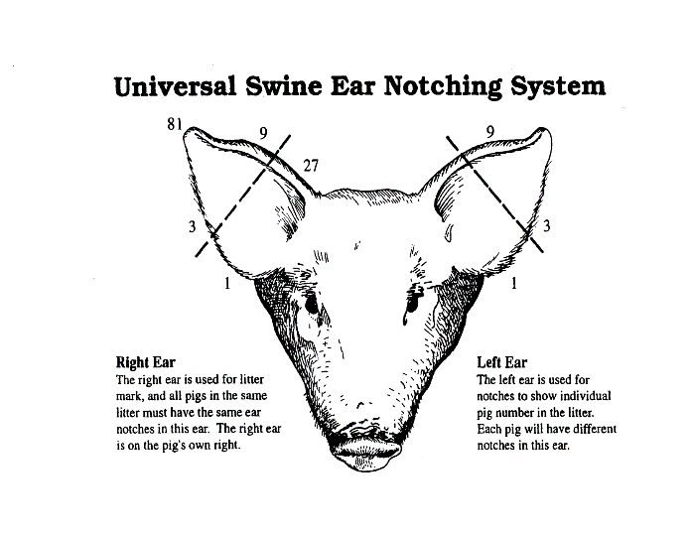
THE ILLUSTRATION BELOW IS THE NUMBERING SYSTEM FOR IDENTIFYING SWINE

