Contact: Chris Corzine
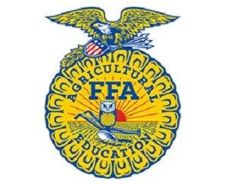
ccorzine@gaaged.org

News Release

For Immediate Release

___(Chapter Name)____ FFA Members and Advisors Attend the 8th Annual Central Region Leadership Rally

Fort Valley, GA - __________________________ (chapter name) FFA members_____________ (member’s names) attended the 8th Annual Central Region Leadership Rally held at Georgia National Fairgrounds and Agricenter in Perry, GA on Monday/Tuesday, September 10/11, 2018. The purpose of the day leadership rally to spark the interest in our FFA members and motivate them to get involved during the upcoming school year in Career Development Events, local Community Service projects, leadership conferences, and conventions. While attending the Central Region Leadership Rally members heard from motivational speaker Eliza McCall from Feeding America/ Second Harvest of South Georgia to learn about the growing issue of hunger among children and teens in Georgia. Students also rotated through various leadership activities lead by the Area 3 and Area 4 officers as well as the central region staff. Through these activities students learned communication, team building and leadership skills that will be used in the ________________________ (chapter name here) FFA chapter. “Students we hope that you take the enthusiasm you shared during the central region rally and use it to focus on your own school’s FFA program,” says Central Region Director, Chris Corzine.
FFA Advisors/Agriculture Teachers that were in attendance included __________ (advisor’s name).
During the Central Region Leadership Rally students also were able to compete in a variety of events that will help the students know what they would like to compete in during the upcoming school year. These Career Clustered Events included: Horticulture Plant Identification, Animal Science Identification, Forestry Identification, Ag Mechanics Identification, an Opening Ceremonies Contest (formal meeting procedures) and an Advisor’s Challenge. The winners of each event included:
________(Student Name (s)_____ __________ from the ______(Chapter Name)____________ FFA Chapter was named the __________(Event they competed in and place)___________.
FFA makes a positive difference in the lives of students by developing their potential for premier leadership, personal growth and career success through agricultural education. FFA membership today is comprised of 649,355 student members in grades sixth through 12 who belong to one of 7,859 local FFA chapters throughout the United States, Puerto Rico and the U.S. Virgin Islands.

###

